GROUP ASSIGNMENT
CT053-3-1 FUNDAMENTALS OF WEB DESIGN AND
DEVELOPMENT
Intake: APU1F2307SE
Lecturer: Wong Chung Wei

Date Assigned: 08-Jan-2024

Date Due: 18-April-2024

Team Members:
- ZAINAL-AABDAIN ALI YAHYA AWADH (TP072684)
- ZEID HARTHA ABOUELFADL AHMED HASSAN (TP075133)
- FAROQ MOHAMMED QAID FAZEA AL-MALIK (TP074410)
- ALI AHMED ALI GAZOULI (TP071525)

Table of Contents
Introduction: 2
Storyboard and Design Document: 2
Important Information About the Website: 3
Interface of Website: 5
Website Storyboard 21
Home Page: 21
Sign Up Page: 22
Training Sessions Page: 23
Player Management Page: 24
Performance Tracking Page: 25
Contact Page: 26
Competition Page: 27
Team Updates Page: 28
Shopping Page: 29
Course Page: 30
Rules Page: 31
Trophy Page: 32
Security And Support Page: 33
Photo Gallery Page: 34
Location Page: 35
Partners Page: 36
Flowchart Diagram of the Website: 37
Our Goal: 38
Future Enhancements: 38
Conclusion 38
References 39
Workload Matrix 40

Introduction:
The APU Futsal CLUB webpage was made for the students and staff of Asia Pacific University. The goal of this website is to make APU futsal easier to find.
Students can look around the Futsal Club, sign up for leagues or teams, and see schedules, game scores, and other news here.

Storyboard and Design Document:
The website has 16 pages that are all related to each other:
- Home
- Sign Up
- Training Sessions
- Player Management
- Performance Tracking
- Contact
- Competition
- Team Updates
- Shopping
- Course
- Rules
- Trophy
- Security and Support
- Photo Gallery
- Location
- Partners

Important Information About the Website:

1-You can find everything you need to know about futsal at Asia Pacific University on this website. We can help you whether you're an experienced player who wants to get better and fight at a high level or a beginner who wants to learn more about the fast-paced and exciting world of futsal. You can take your futsal game to the next level here with the help of friendly other players, dedicated teachers, and all the tools you need.
2-Our website has an extensive futsal schedule that is changed often. No more rushing around to find out when practice is or missing important game news. You can make a good plan for the week by looking at the calendar. This way, you won't miss any practice sessions or be late for an important game. This lets you keep up with your schoolwork without any problems while still giving your soccer journey your full attention.
3-Our website is easy for anyone to use to sign up for events, teams, and intramural play. You're ready to play as soon as you go to the signup page and fill in the necessary information. Our website has everything you need, whether you want to play in a serious league, join a casual intramural team or just find people to practice with.
4-We know that it's important for athletes to stay updated. You can always find the latest news, results, and information about the APU Futsal Club on our website. Do not miss out on important news about future tournaments, team meetings, player profiles, or even futsal coaching clinics. Stay up to date on the game and be an involved member of the APU Futsal community by checking back often.
5-For easy browsing, we've put a lot of thought into making the style user-friendly. All parts of the website are easy to get to thanks to a clear and easy-to-use menu bar. This lets you find the information you need quickly and easily. The website also has useful information that is given concisely. It's easy to find everything you need in one place, whether you're looking for practice times, information on how to register or the latest news.

6-You can get in touch with coaches and program managers through the website's "Contact" page or ask any questions you may have. Our dedicated team is here to help you, whether you're a new player looking for tips or an experienced athlete with unique concerns. Feel free to get in touch if you have any questions, ideas, or just want to meet with other people in the APU Futsal community.
7-For students who are really into the sport, this website was made just for APU Futsal, making the experience easier. Don't waste time looking through general college sports pages; everything you need to know about futsal is here. We can meet the unique needs of the futsal community and give you the most relevant and up-to-date information thanks to this platform.

Interface of Website:

Home Page:
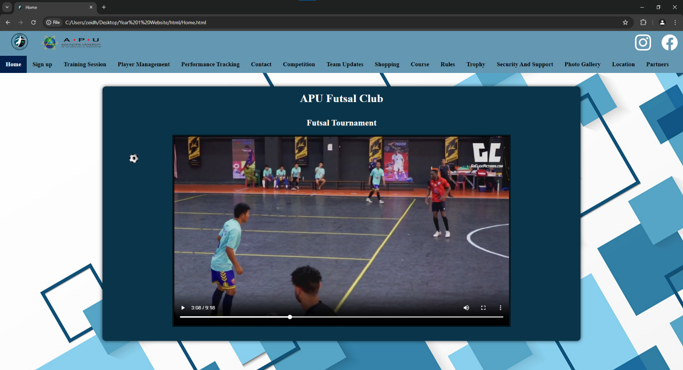

Sign Up Page:
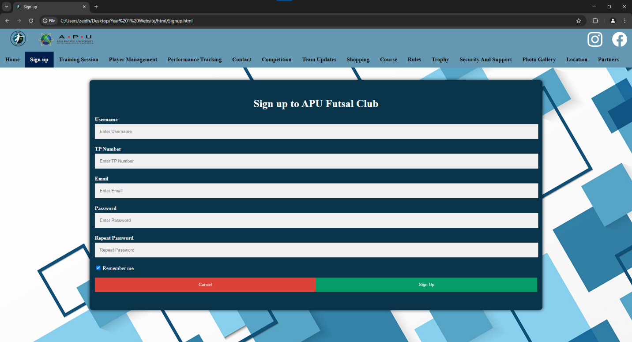

Training Sessions Page:
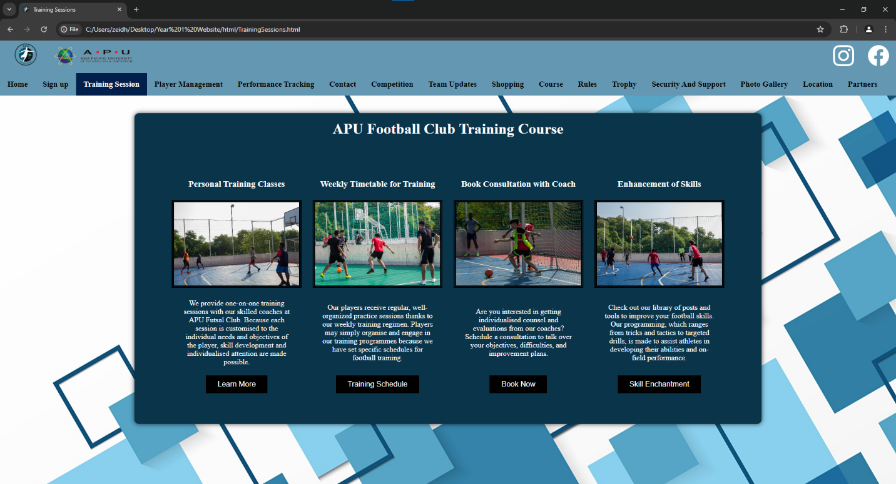

Player Management Page:
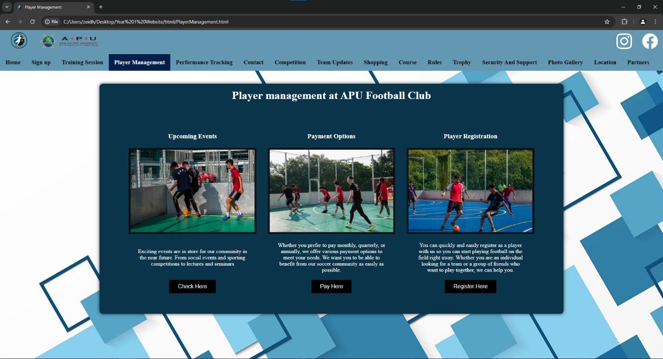

Performance Tracking Page:
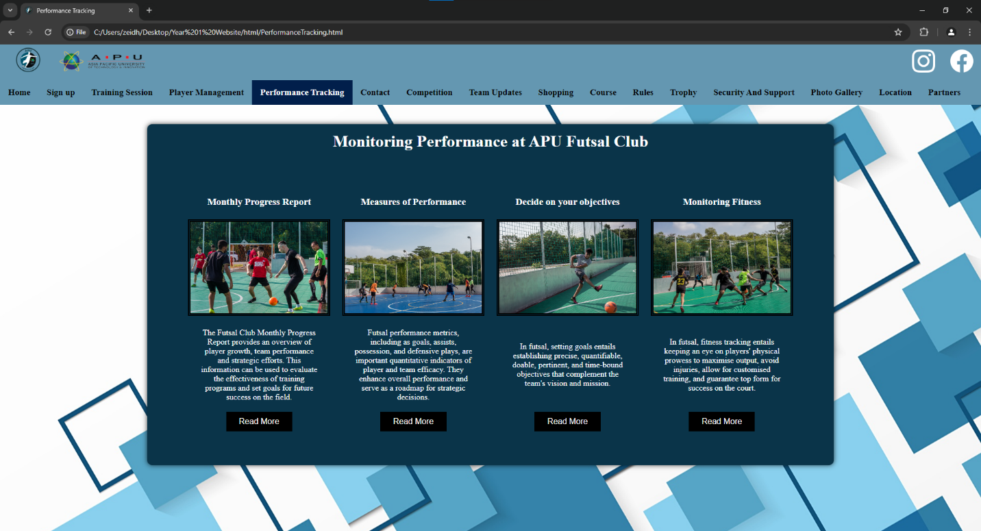

Contact Page:
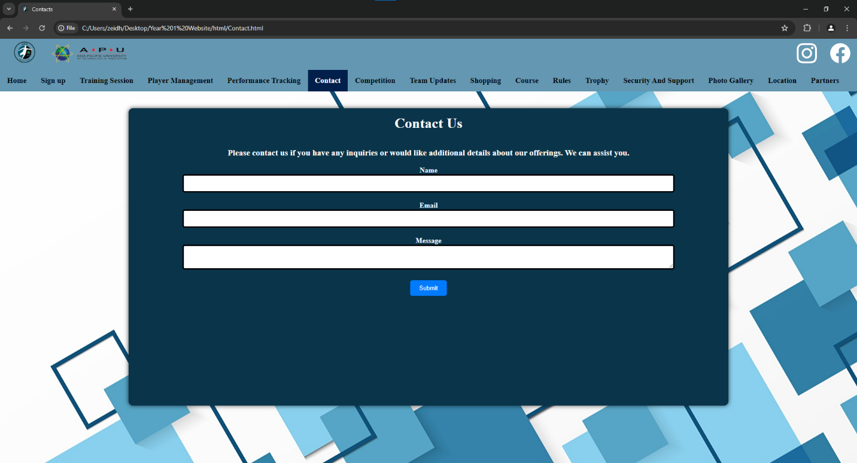

Competition Page:
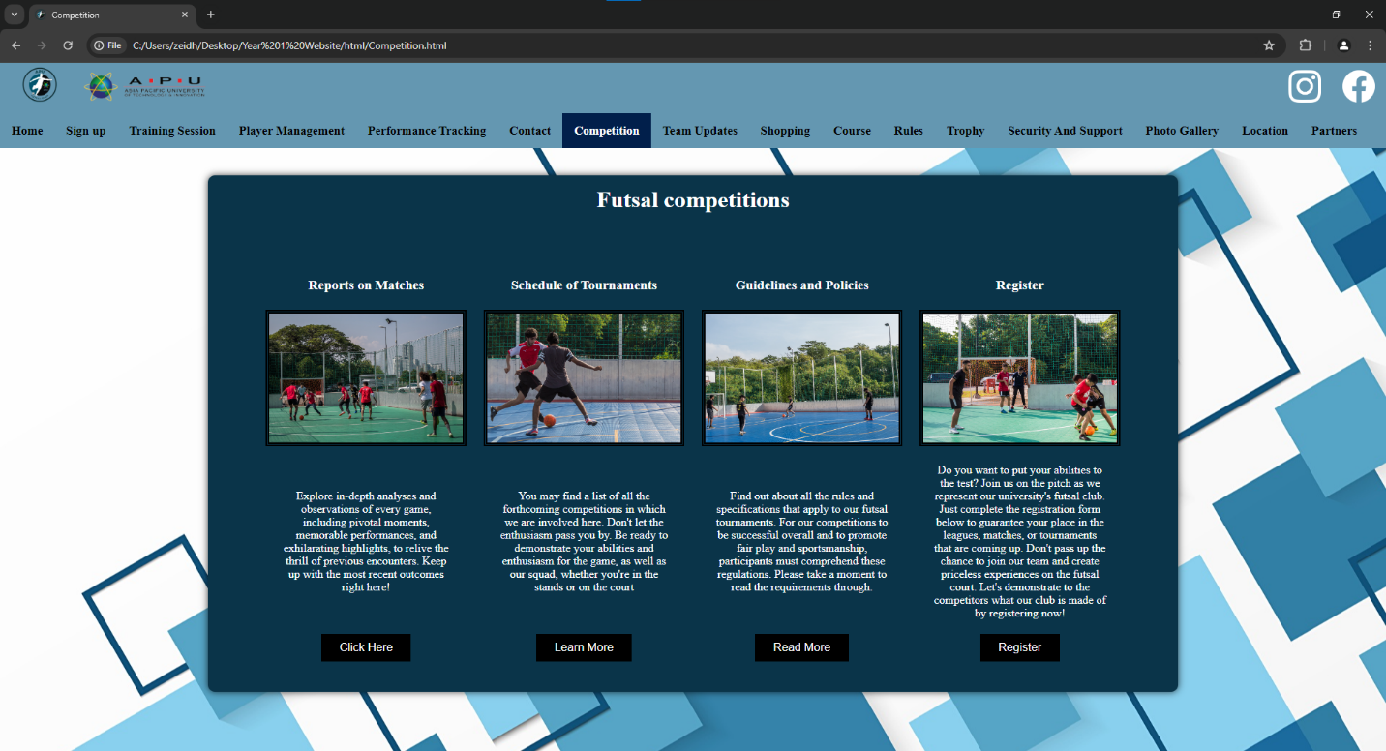

Team Updates Page:
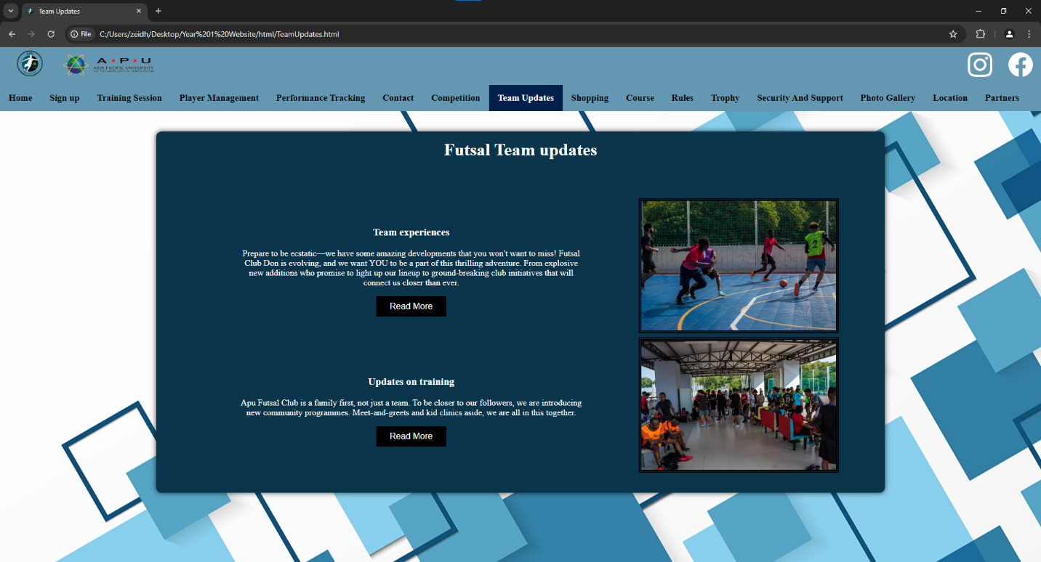

Shopping Page:
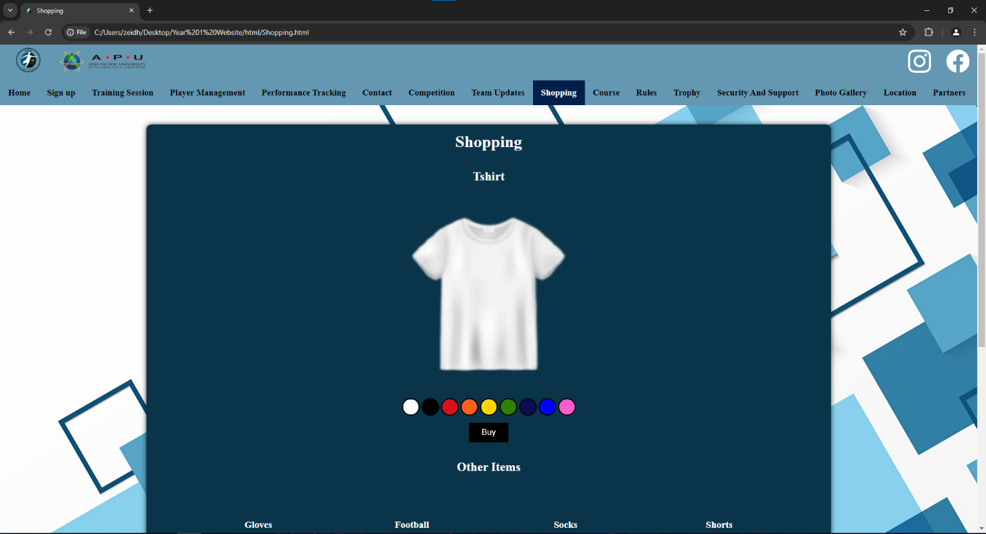
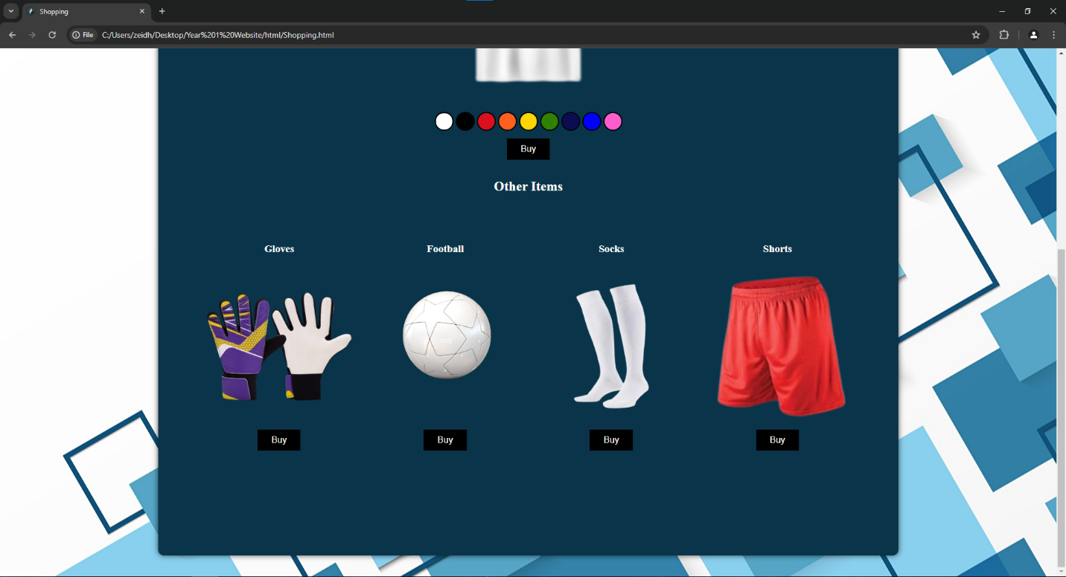

Course Page:
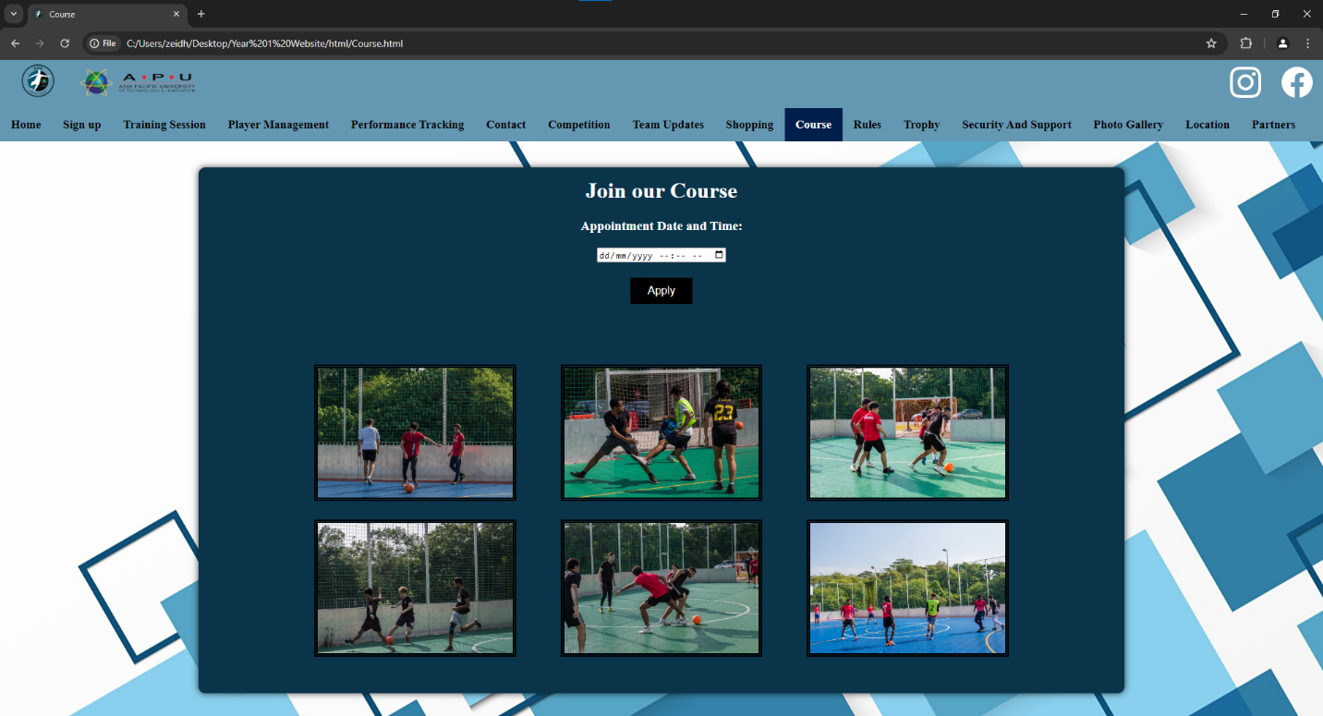

Rules Page:
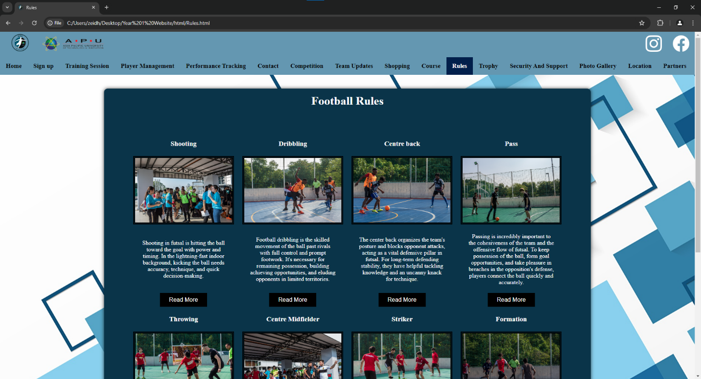
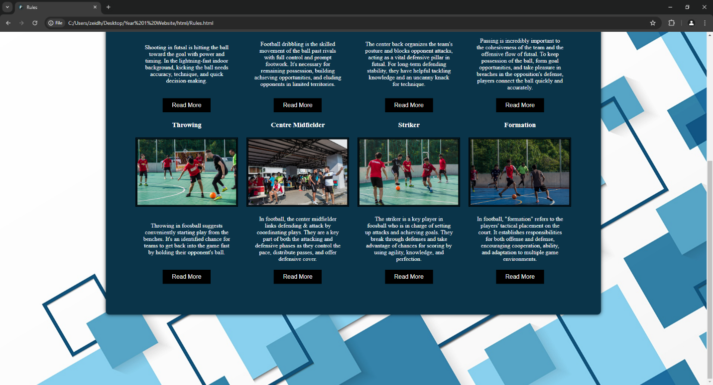

Trophy Page:
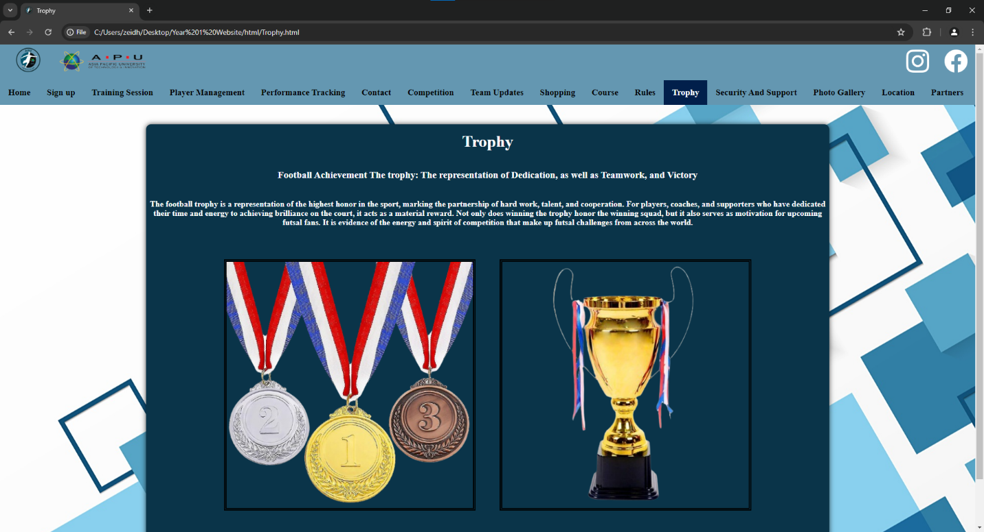

Security And Support Page:
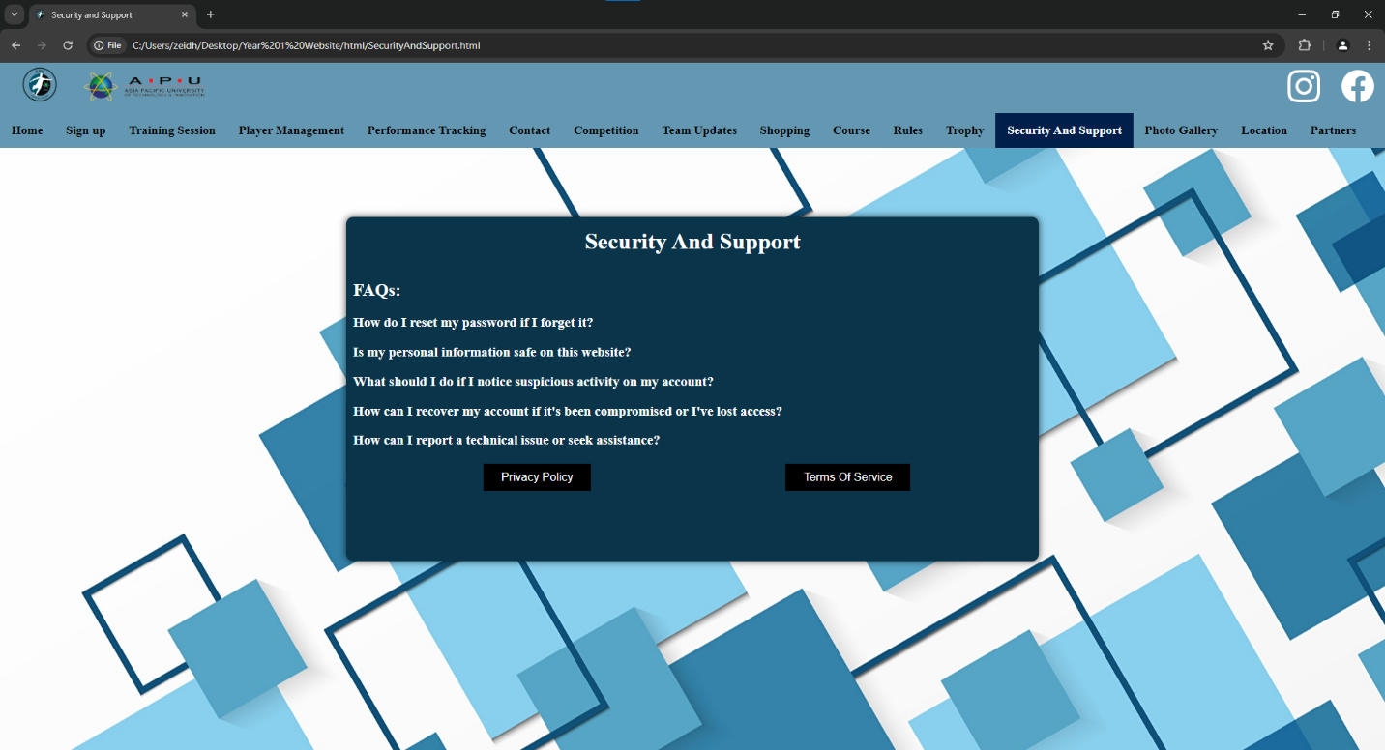

Photo Gallery Page:
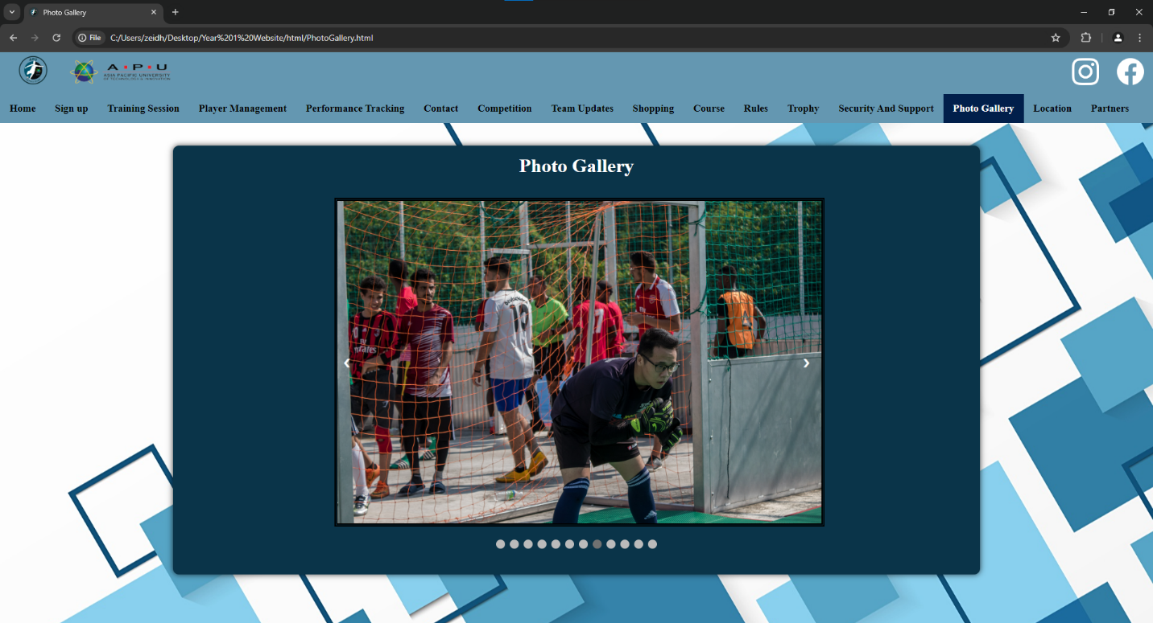

Location Page:
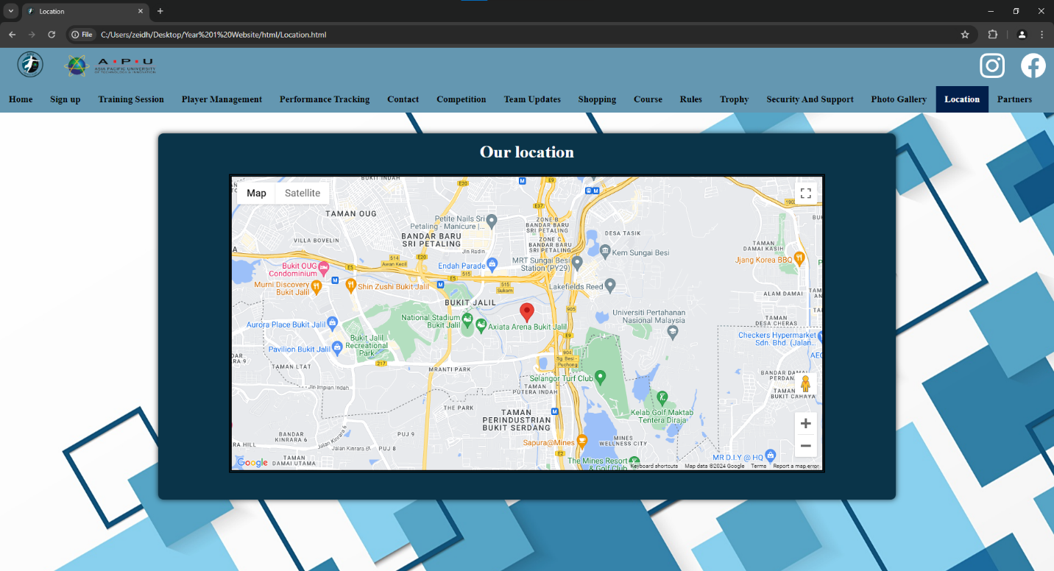

Partners Page:


Website Storyboard

Home Page:
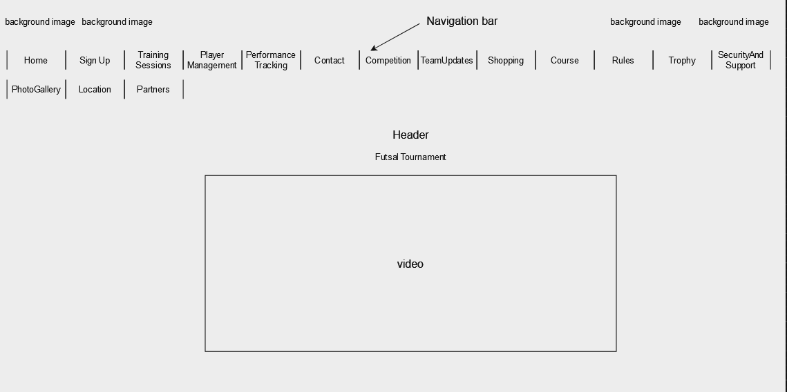

Sign Up Page:

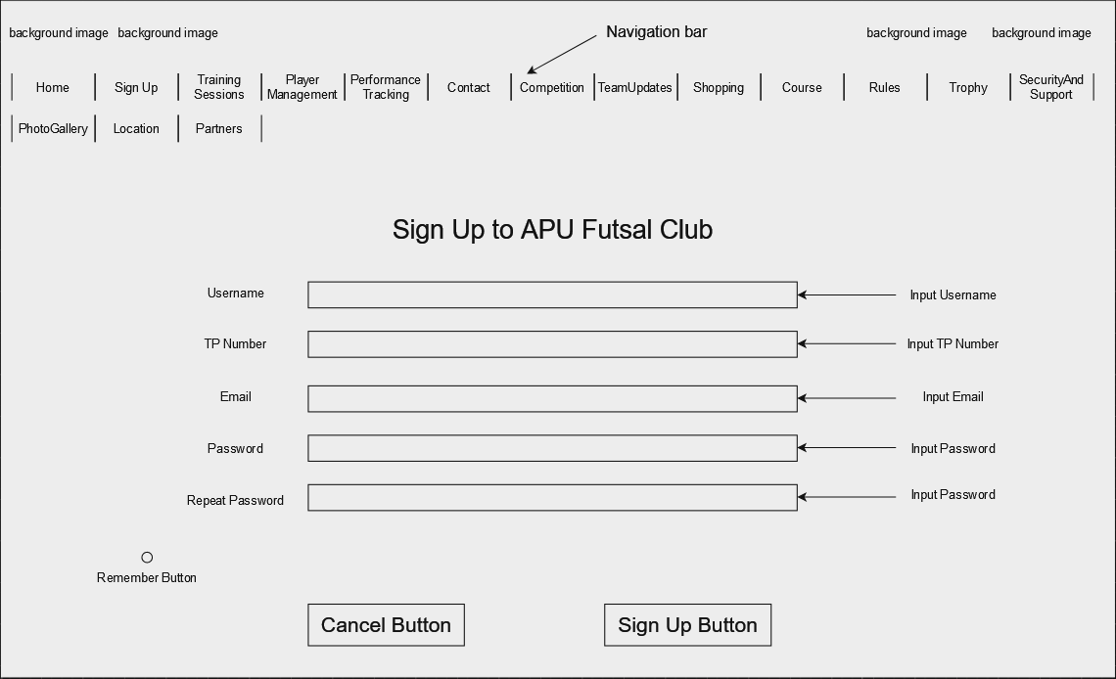

Training Sessions Page:

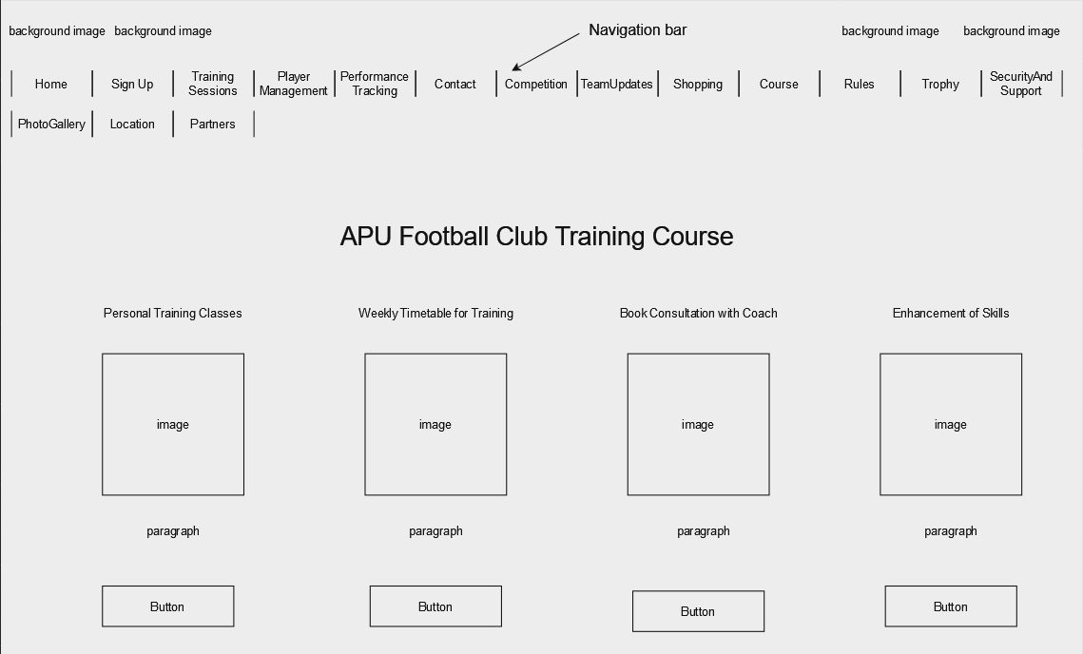

Player Management Page:

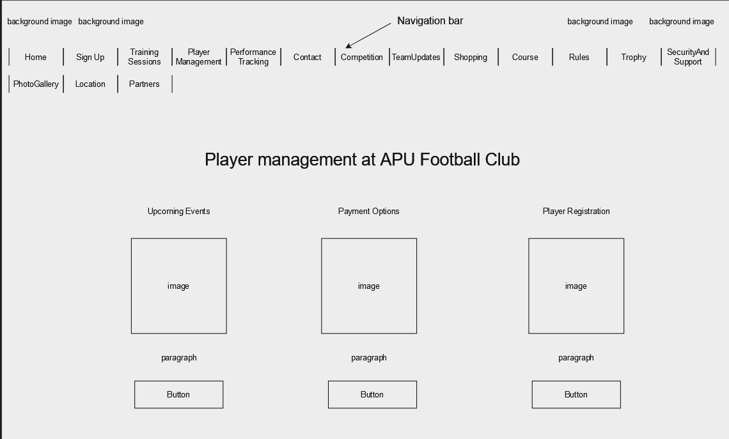

Performance Tracking Page:

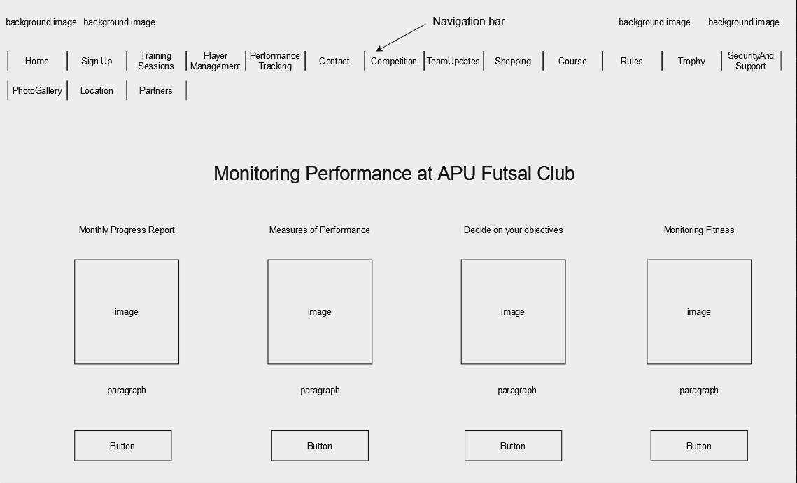

Contact Page:

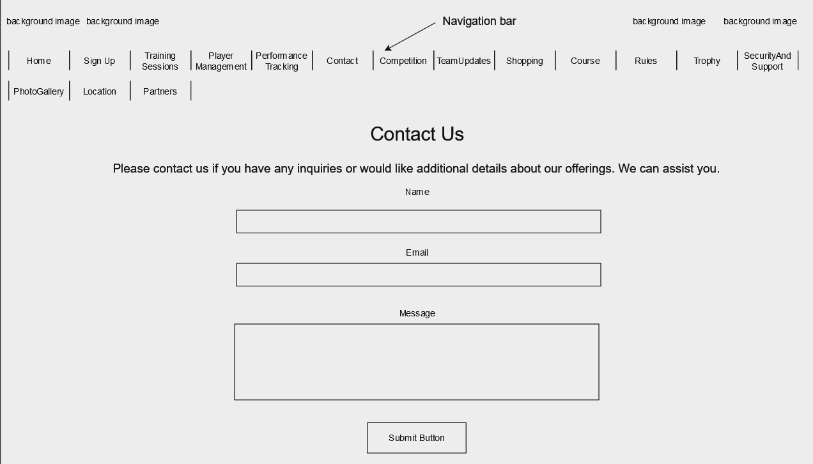

Competition Page:

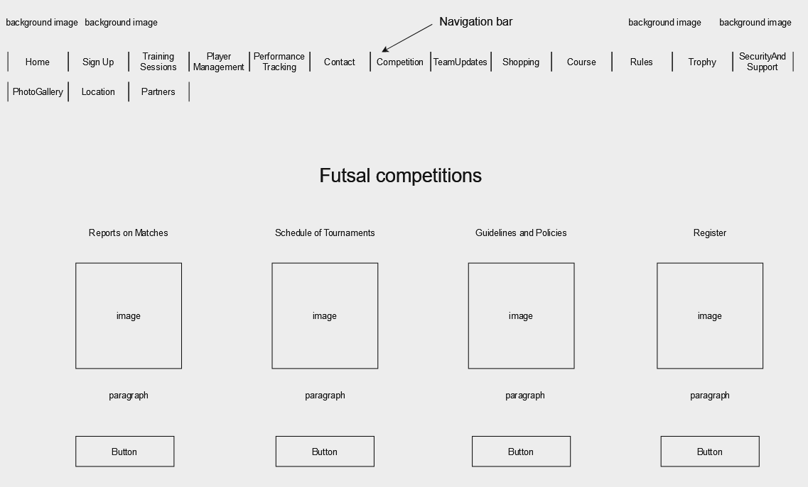

Team Updates Page:

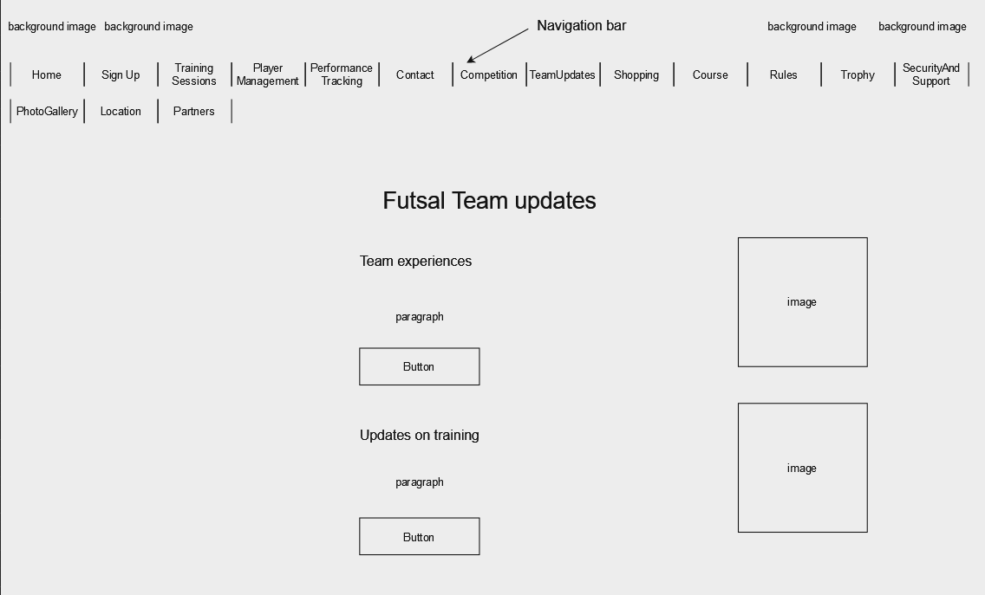

Shopping Page:

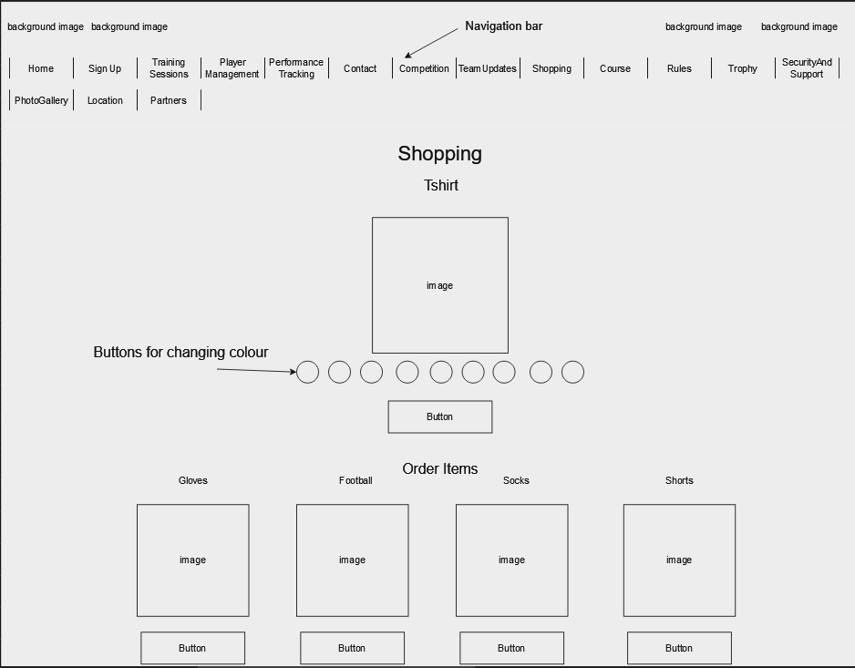

Course Page:

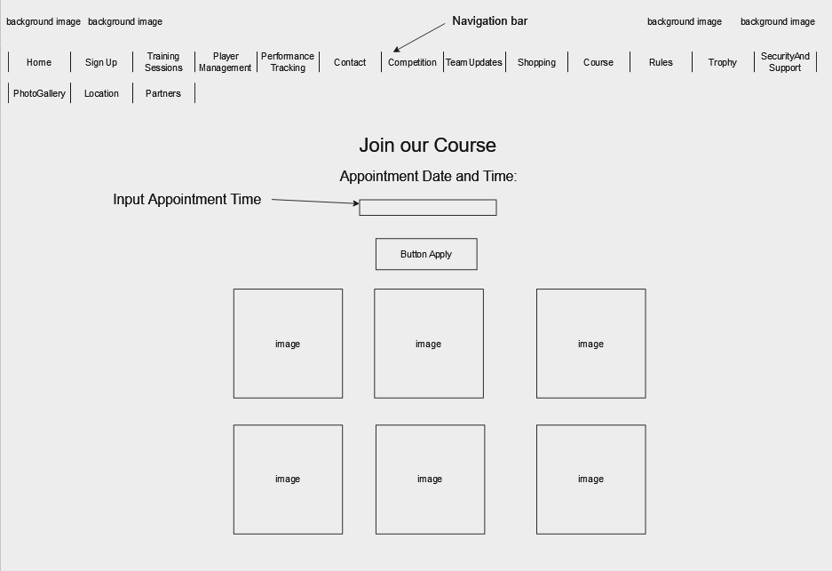

Rules Page:

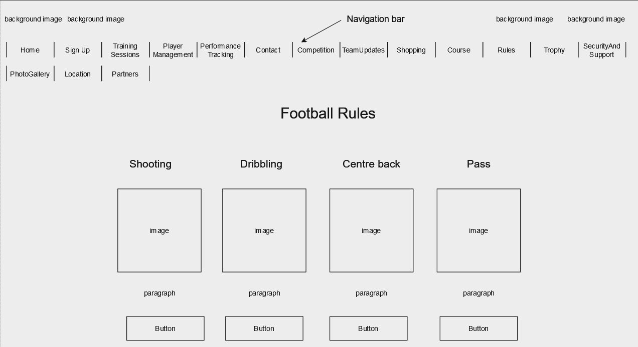
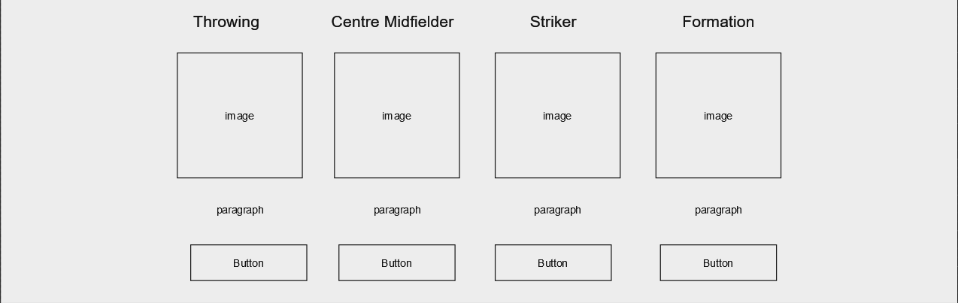

Trophy Page:

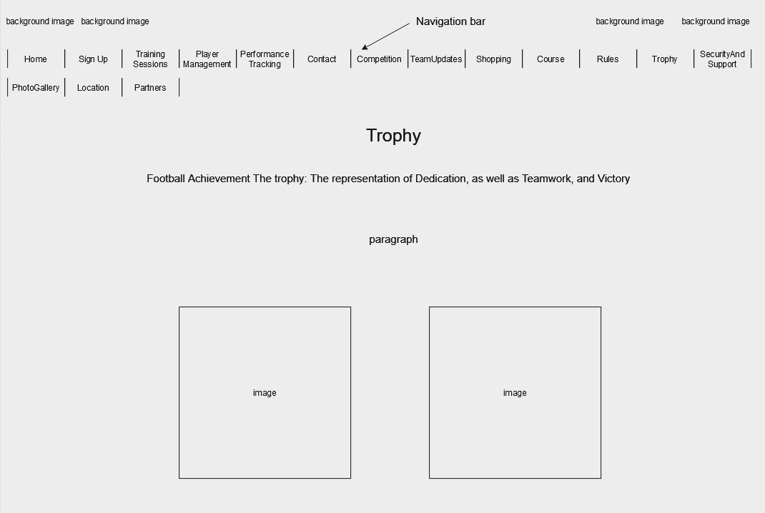

Security And Support Page:

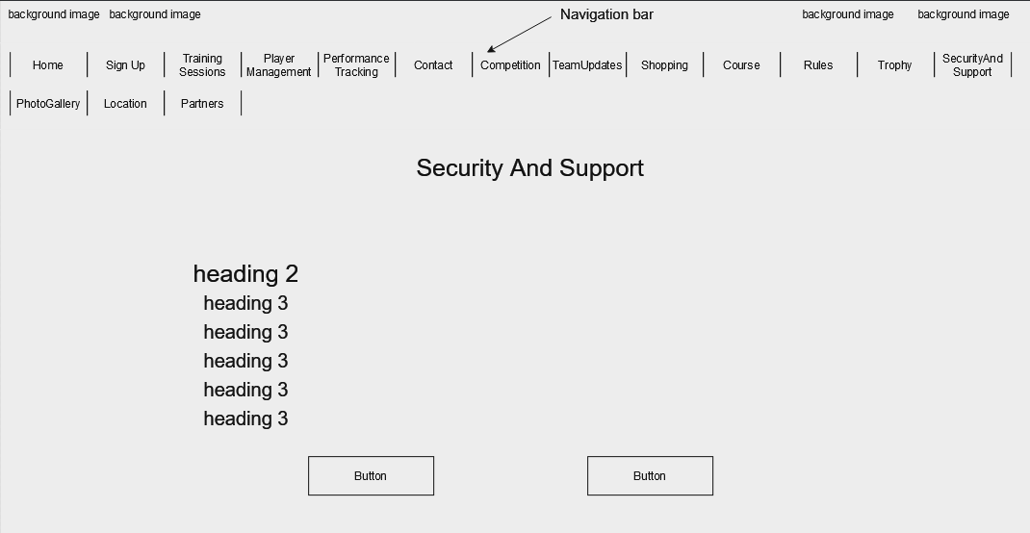

Photo Gallery Page:

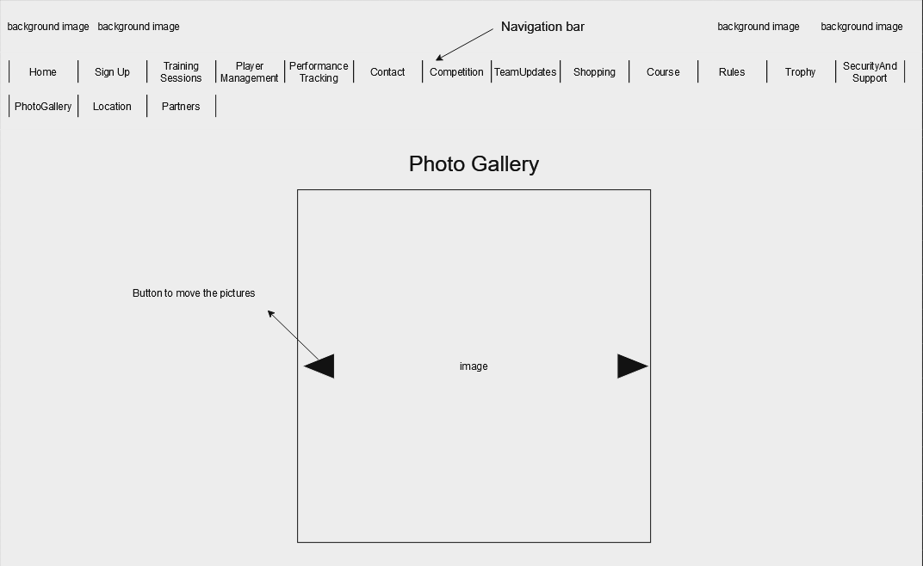

Location Page:

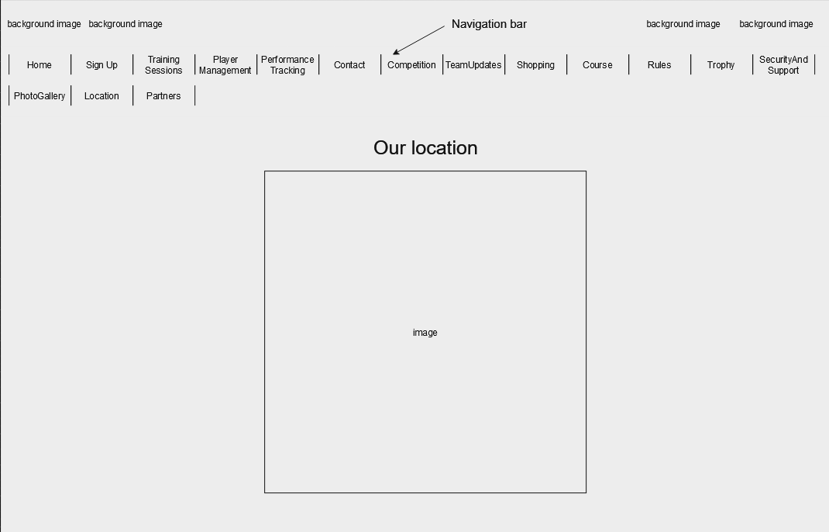

Partners Page:

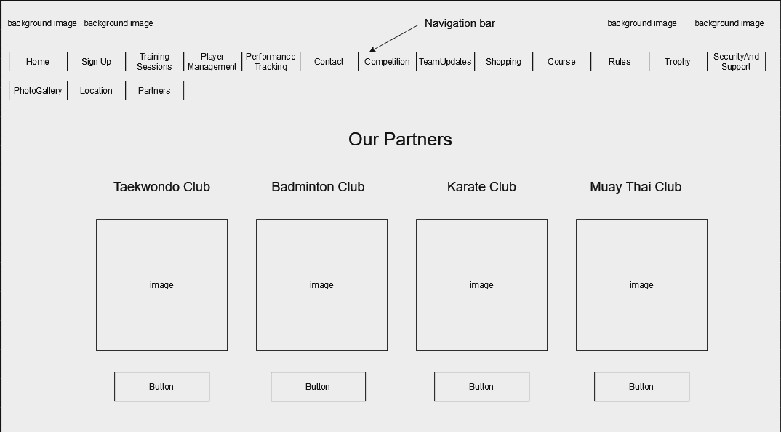

Flowchart Diagram of the Website:

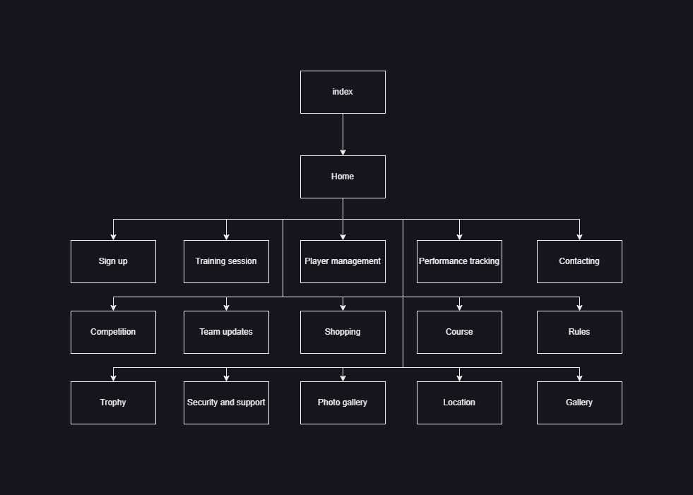

Our Goal:
The goal of this new website is to help student players with their problems. No longer do you have to wait in long lines at student affairs. Now, our website makes it easy to sign up for the APU Futsal Club in just a few minutes.
No more clashes of plans! The website is set up so that different sports groups' training days and times don't clash. This means you can join more than one club without having to worry about making time for them all.
Our News area will keep you up to date on what's going on in the game. Find out about future Futsal games, past tournaments, and APU's athletic accomplishments.
Not sure how to get to the court? Not a problem! On the website, there is a tab called "Location" that has clear information to help new students quickly find the futsal court.
What Happens Behind the Scenes
There were some problems that came up while building the website. We sometimes ran into problems, such as content that was too big, broken CSS code, and issues with resizing images. But don't worry, soccer fans! We got past these problems by trying things out and learning from our mistakes. We used online tools and what we learned in class to make sure the user experience was smooth.

Future Enhancements:
There were quite a lot of more things that could have been added for example:
- The website's live chat help is another one of these. It will give users a way to talk to reps if they have any issues or problems while registering. This would make things better for users.
- A search bar would save people time by letting them find what they need without having to go to all 16 pages one by one.
- Make a database that saves all the usernames and passwords for the students.

Conclusion

With the new website, you can easily access all of Futsal's advantages. Easy registration, clear training plans, and news about all things Futsal at APU. Furthermore, the location tab makes sure you never miss a practice lesson. The new website’s tools and easy-to-use layout will make your Futsal experience at APU better.

References

HTML tutorial. (n.d.). https://www.w3schools.com/html/default.asp
HTML Images. (n.d.). https://www.w3schools.com/html/html_images.asp
JavaScript output. (n.d.). https://www.w3schools.com/js/js_output.asp
CSS Syntax. (n.d.). https://www.w3schools.com/css/css_syntax.asp

Workload Matrix
Member | Website Page
ZAINAL-AABDAIN ALI YAHYA AWADH | Home.html
ZAINAL-AABDAIN ALI YAHYA AWADH | Partners.html
ZAINAL-AABDAIN ALI YAHYA AWADH | Competition.html
ZAINAL-AABDAIN ALI YAHYA AWADH | TeamUpdates.html
ZEID HARTHA ABOUELFADL HASSAN | Location.html
ZEID HARTHA ABOUELFADL HASSAN | Contanct.html
ZEID HARTHA ABOUELFADL HASSAN | PerformanceTracking.html
ZEID HARTHA ABOUELFADL HASSAN | PlayerManagement.html
FAROQ MOHAMMED QAID AL-MALIK | PhotoGallery.html
FAROQ MOHAMMED QAID AL-MALIK | Course.html
FAROQ MOHAMMED QAID AL-MALIK | Rules.html
FAROQ MOHAMMED QAID AL-MALIK | SecurityAndSupport.html
ALI AHMED ALI GAZOULI | Shopping.html
ALI AHMED ALI GAZOULI | TrainingSessions.html
ALI AHMED ALI GAZOULI | Trophy.html
ALI AHMED ALI GAZOULI | Signup.html

